**New DIRECTORY Feature in iHealthHome**

iHealthHome has updated the system with a new Directory allowing you to manage all contacts in your company from one place. This new feature also allows you to make people within the system inactive so they will no longer show in your person dropdowns. Please review the information below on how this new feature works.

Click the new **Directory** button at the top of your screen.

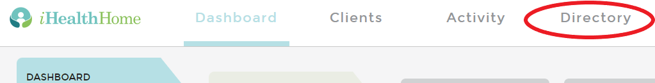

The default view is of **All** people in your company. You can narrow this list by clicking on **Client**, **Employee**, **Physician** or **Contact** and this will limit the list to individuals in each of these categories.

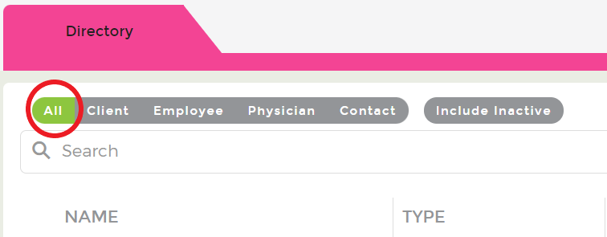

This new feature allows you to see how many individuals a person is associated with in the system.

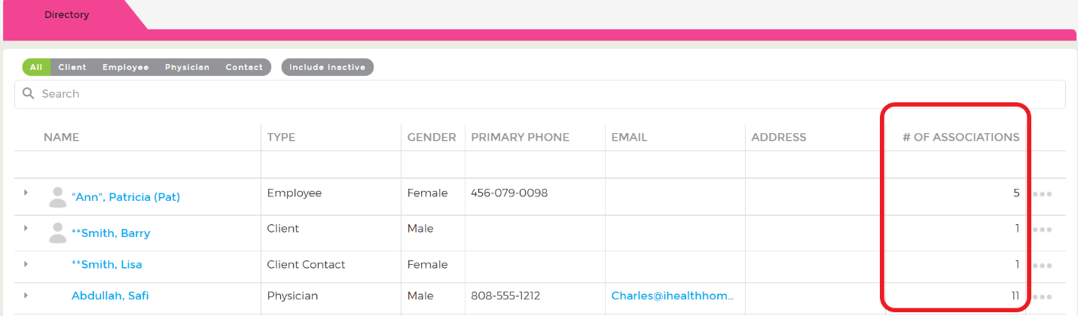

Click the “**…**” to the far right and you can view all of these associations, edit this person’s demographic information or make them Inactive.

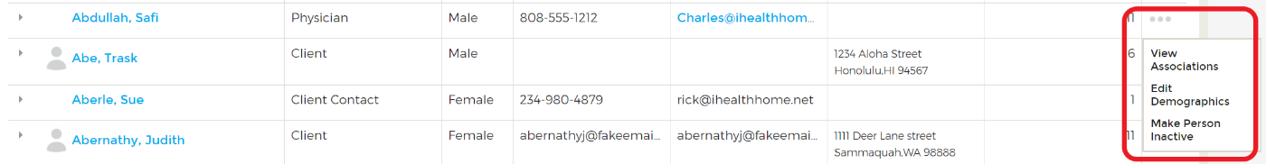

When you select View Associations a new window will pop up with a list of all people linked to this individual.

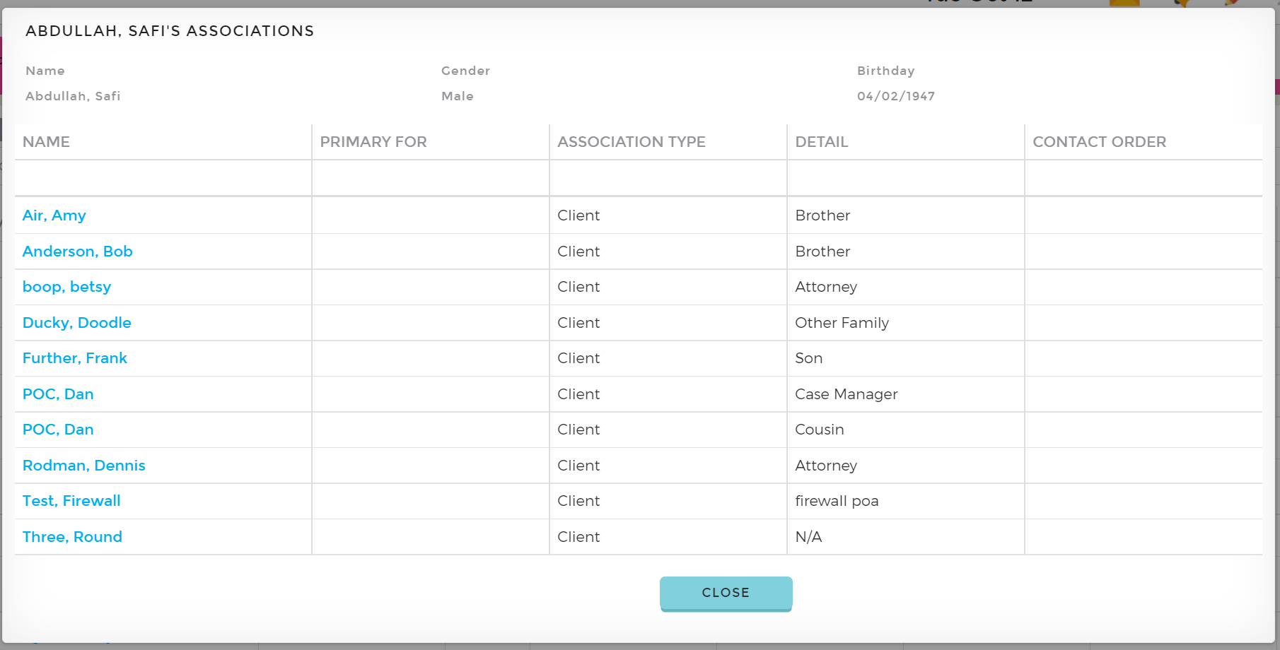

When you select **Edit Demographics** a new window will open where you can edit information and save updates. This is the same feature as using the Person Search from your main Dashboard.

For any person that IS NOT a client, if you select **Make Person Inactive** you will get a pop up confirming that you want to do this. Click **yes** and this individual will be moved to the Inactive list and will be hidden from all person drop down lists and Client files where they are linked to.

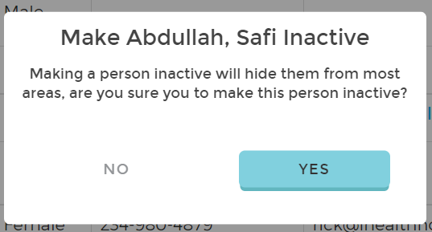

For any person that IS A CLIENT, when you make them inactive you will get a pop up that allows you to make some additional selections.

1. Select if you want the client to be made “**Inactive**” or “**Archived**” – these are the same options available from the Client Admin form if you change the client status there.

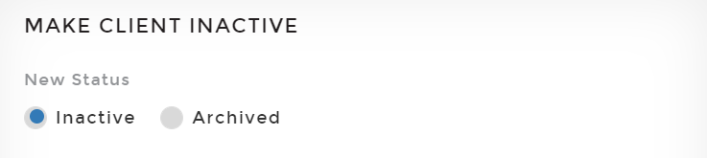

1. You are also given the option to “Select all contacts not in use elsewhere to make inactive”. Any individuals that are linked to other clients in the system will be greyed out, you can select individuals that are only associated with this client and make them inactive also.

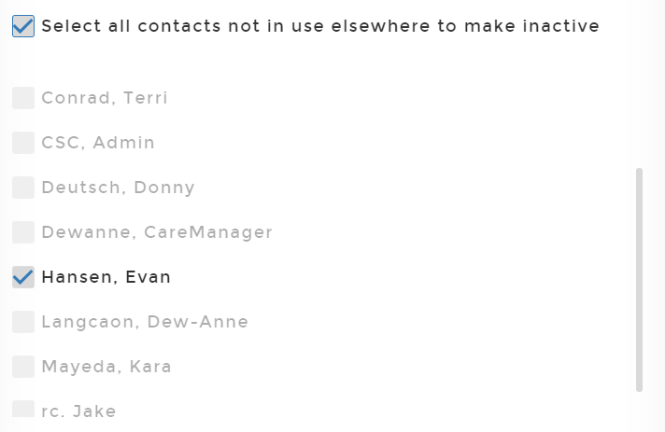

1. Depending on what features your Company is using you will have the options to end other features associated with this client. NOTE: you may not see this full list if your company does not use all of these features.

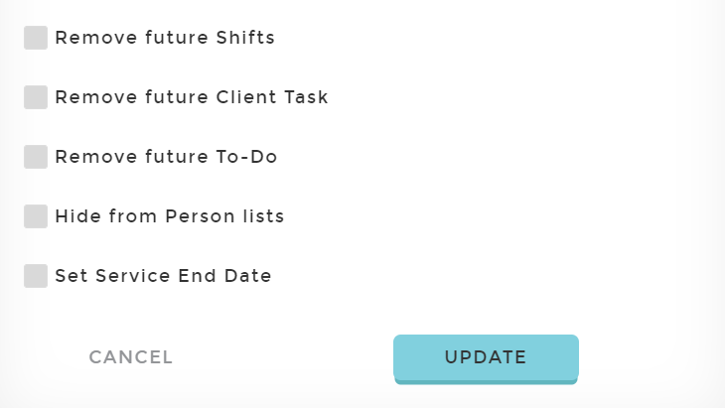

1. If you are using caregiver scheduling and tasking you can select to remove all future shifts and tasks – this would be from today forward (you cannot set another date)
2. Remove future To-do’s from today forward if using them
3. Hide from Person lists – this will also inactivate them as a person
4. Set Service End Date (and outcome) – this will populate the selected date for all services in the client’s file with no end date already listed

Once an individual is made inactive, you can find them by clicking the **Include Inactive** button. Inactive people will have an “*” in front of their last name

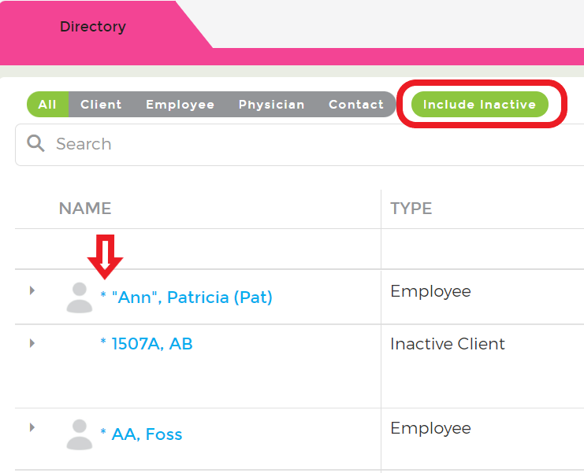

You can make the active again by clicking the “**…**” to the far right and selecting **Make Person Active**

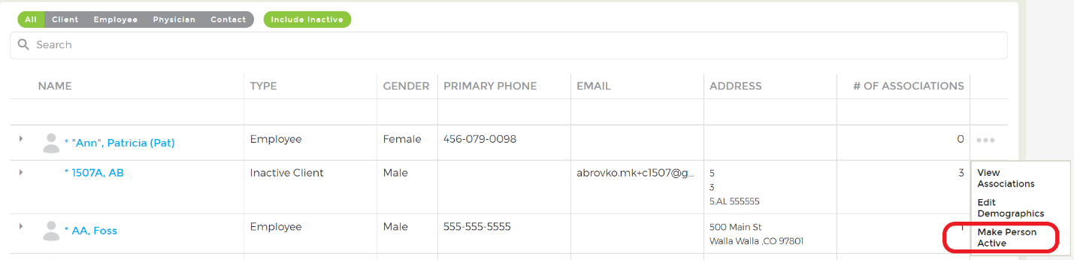

You will get a pop up confirming that you want to do this, click **Yes**

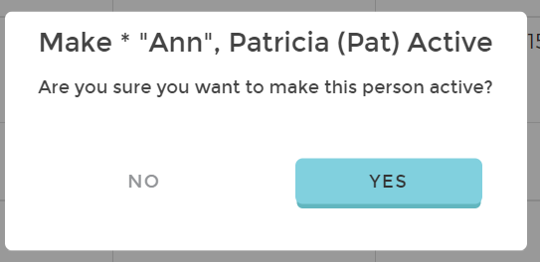

This will move them back into your person lists as well as add them back to any client’s files they were previously associated with.

